Social Media Posts:

Audience | Content (text) for post | Image file name for post
People with an intellectual or developmental disability | You can get free help to quit smoking, vaping or other tobacco.  Call 1-800-QUIT-NOW (1-800-784-8669) or visit quitnow.net/oregon to get counseling and free quit smoking medications to help you quit for good! | 1a – Facebook  1b – Instagram  1c – TikTok  Example of image:  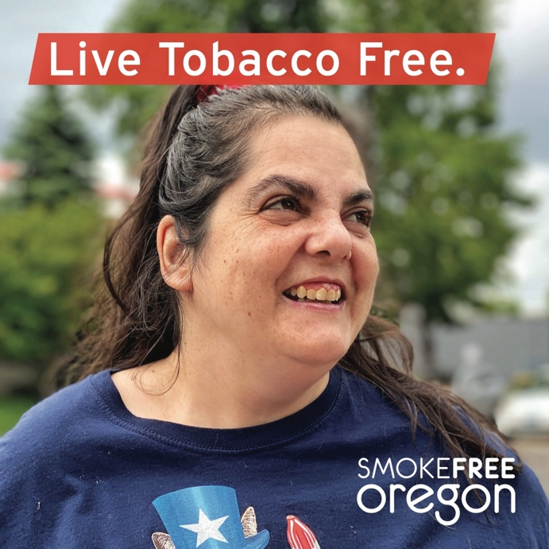
People with a disability that is not intellectual or developmental | Did you know the tobacco industry targets people living with disabilities? They want to addict you to cigarettes and other tobacco products so that you become a customer for life.  Don’t let them take any more of your health or money. Call the Oregon Tobacco Quit Line to get FREE quit smoking medications (like nicotine replacement gum and patches) and counseling to help you quit for good.  Call 1-800-QUIT-NOW (1-800-784-8669) or visit quitnow.net/oregon. | 2a – Facebook  2b – Instagram  2c – TikTok  Example of image:  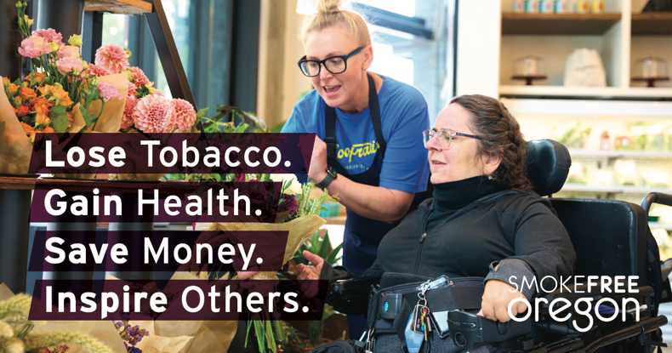
People with a disability that is not intellectual or developmental | Remember, it’s OK to take your time when quitting tobacco! Consider slowly cutting down on how much tobacco you use or smoke each day. Quit smoking medications, like gum or patches, can help. Sometimes, slow and steady wins the race.  For more tips and help getting FREE medications (like gum and patches), call 1-800-QUIT-NOW (1-800-784-8669) or visit quitnow.net/oregon. | 3a – Facebook  3b – Instagram  3c – TikTok  Example of image:  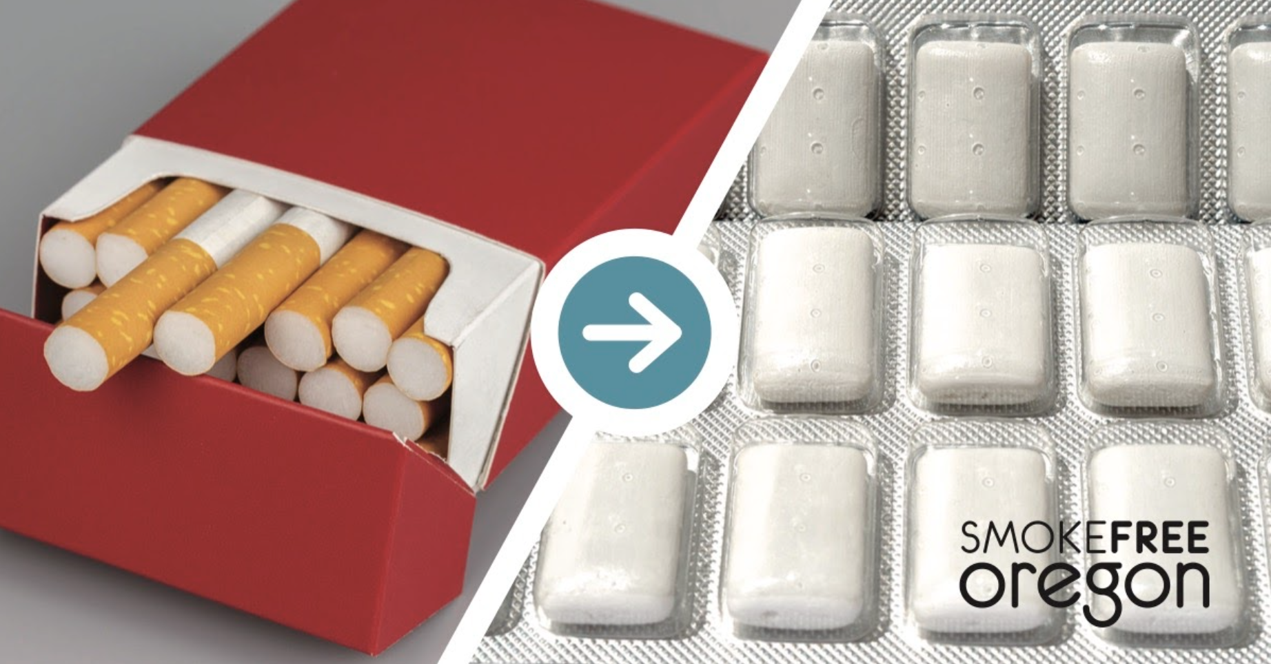
People with a disability that is not intellectual or developmental | You already know that using tobacco can harm your health, but do you know what you can get back when you quit? Here are some ways your life can improve when you stop using tobacco:  - Ability to breathe better  - Increased blood flow and circulation  - Reduced risk of pressure sores, heart attack, stroke and cancer  - Potential savings of more than $3,000 a year  Don’t wait! Call 1-800-QUIT-NOW (1-800-784-8669) to get FREE counseling and quit smoking medications (like nicotine replacement patches and gum) to help you quit for good. | 4a – Facebook  4b – Instagram  4c – TikTok  Example of image:  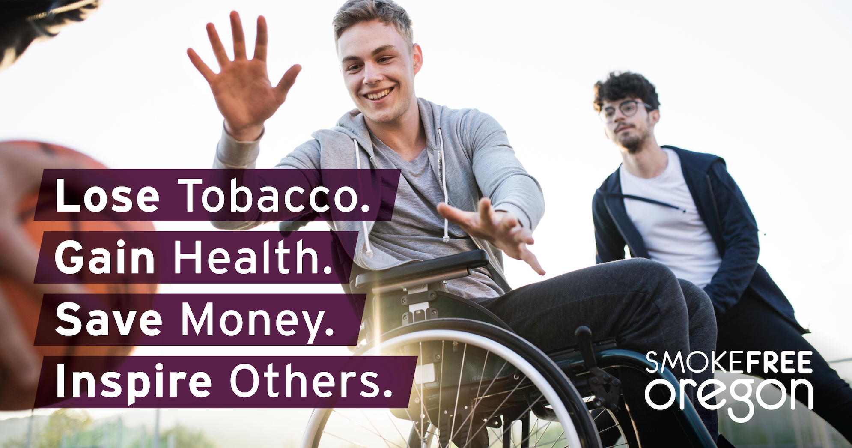
Caregivers and support providers | Supporting someone on their path to quit tobacco is an act of care that will positively impact both you and the health of the person you care for. The Oregon Tobacco Quit Line provides FREE support to help you and those you care for in quitting tobacco for good.  Call 1-800-QUIT-NOW (1-800-784-8669) or visit quitnow.net/oregon. | 5a – Facebook  5b – Instagram  5c – TikTok  Example of image:  